**Work case №6**

**Виконав Когут Богдан**

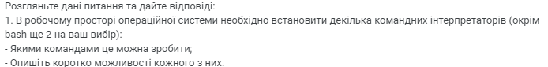

In addition to **bash**, you can install: **zsh** (Z Shell), **fish** (Friendly Interactive Shell)

Commands for Installation:

For zsh:

sudo apt update

sudo apt install zsh

or

For fish:

sudo apt update

sudo apt install fish

Brief Overview of Features

**1. Bash (Bourne Again Shell)**

Features:

Default shell in most Linux distributions.

Supports scripting (bash scripts).

Extensive set of tools for text processing and task automation.

Command history, autocomplete, and environment variable configuration.

**2. Zsh (Z Shell)**

**Features**:

Advanced autocomplete with suggestions.

Plugin and theme support (e.g., via **oh-my-zsh**).

More customization options compared to bash.

Reverse search and enhanced alias capabilities.

**3. Fish (Friendly Interactive Shell)**

**Features**:

User-friendly and intuitive interface.

Command autocomplete based on history and available options.

Built-in syntax highlighting and color formatting.

No need for plugins to access basic conveniences (everything is built-in).

**Виконав Трощинський Ярослав**

2. Необхідно створити 10 нових користувачі в вашій системі та розподілити їх по групам:

- Technical support (технічна підтримка, системні адміністратори);

- Developers (розробники, технічні спеціалісти свого профілю);

- Financiers (бухгалтерія, економісти тощо);

- Founders (керівництво);

- Guests (гості).

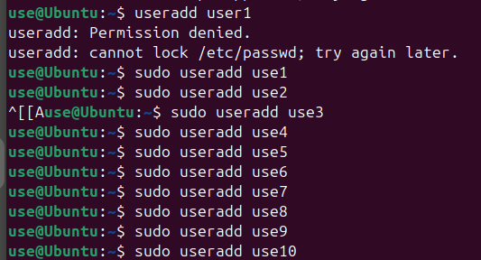

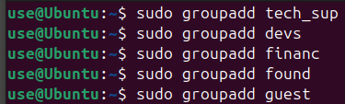

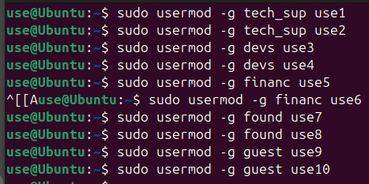

3. Для кожного з користувачів визначити його командний інтерпретатор за замовчуванням:

- Technical support – bash;

- Developers – командний інтерпретатор 1 (завдання 1);

- Financiers – заборонити доступ до командних інтерпретаторів;

- Founders – командний інтерпретатор 2 (завдання 1);

- Guests – заборонити доступ до командних інтерпретаторів.





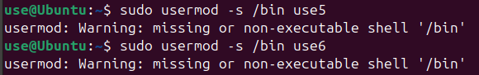



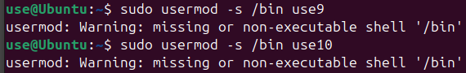

4. Продемонструвати приклади роботи кожної групи користувачів у своєму командному інтерпретаторі – наприклад збір відомостей про систему, визначення базової конфігурації, системної дати, поточних каталогів тощо.

I chose to see if users can do this things: see what processes are active, command “*ps”* and see a via command “*date*”

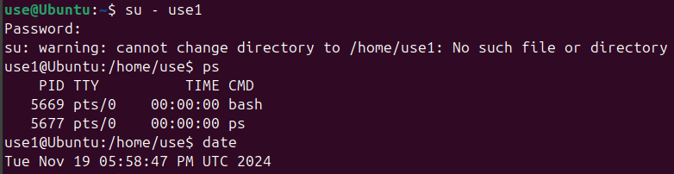

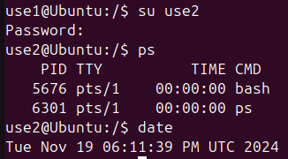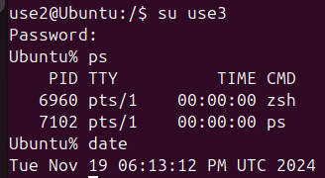

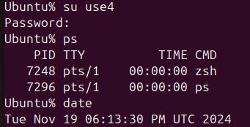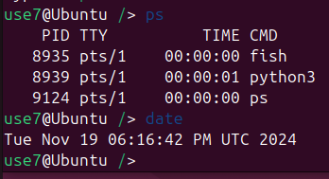

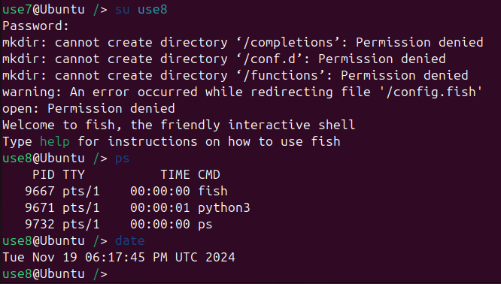

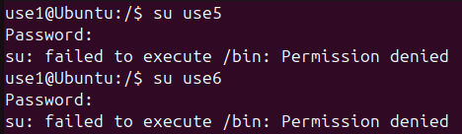

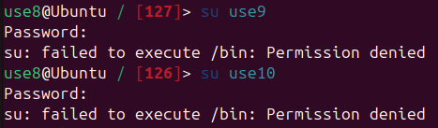

**Виконав Михайленко Олексій**

**Conclusion**  
This task showcased the robust capabilities of Linux systems in tailoring the working environment to suit users with diverse roles and responsibilities. By integrating different command interpreters, it became evident how flexibility in customization can significantly enhance user productivity and efficiency. For instance, developers benefited from advanced features in Zsh, such as plugins and scripting tools, while the Founders group enjoyed the intuitive and visually appealing interface of Fish, making it easier for non-technical users to perform essential operations.

Restricting access to command interpreters for groups such as Financiers and Guests also highlighted the importance of security in a multi-user environment. This measure not only safeguards sensitive system configurations but also prevents unauthorized actions that could disrupt system integrity.

The ability to assign specific command-line environments to different user groups reflects the strength of Linux in managing a wide variety of workflows within a single system. Overall, the task demonstrated how thoughtful configuration of tools and permissions can optimize system usability, ensure security, and create an efficient working environment tailored to the needs of each group.